**Docker Task -3**

**Task Description:**

Create a custom docker image for nginx and deploy it using docker compose, where the volume bind mount should be at /var/opt/nginx location. Push the created custom docker image to your docker-hub.

**Techstacks needs to be used :**

* AWS EC2
* Docker
* Docker Compose

**Output Screenshots:**

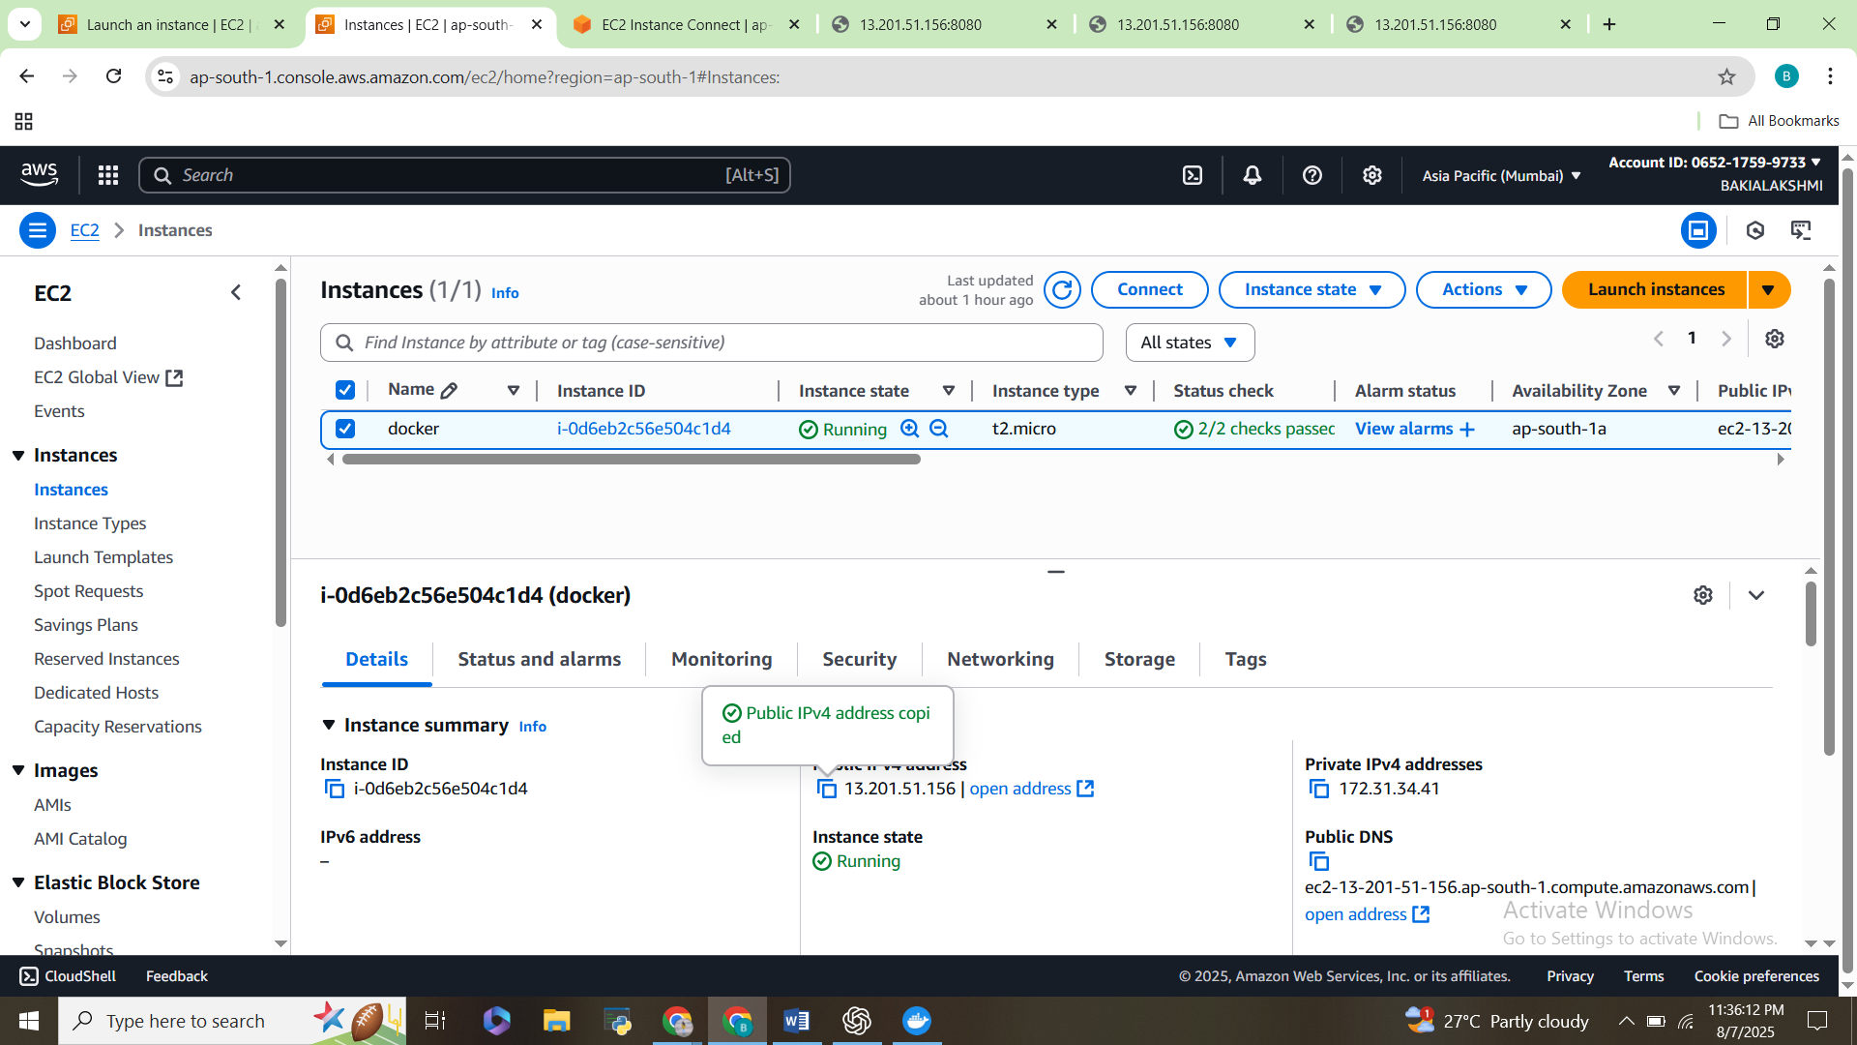

**1)Create a project folder**

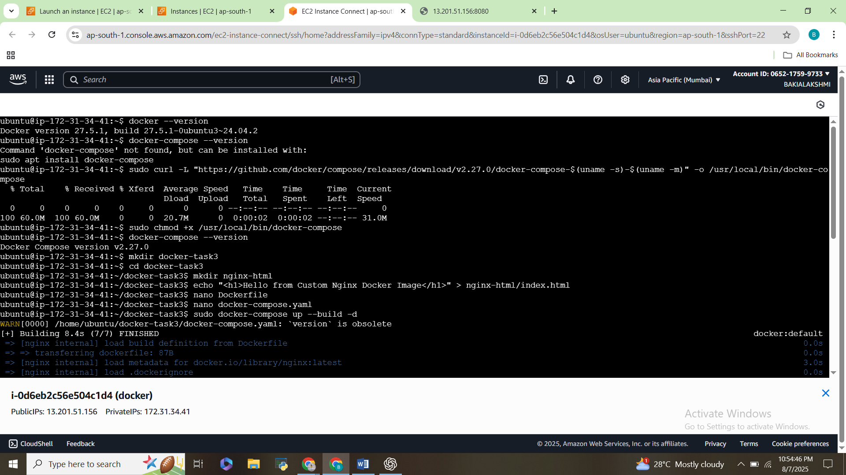

**2)Create a Dockerfile, docker-compose.yaml**

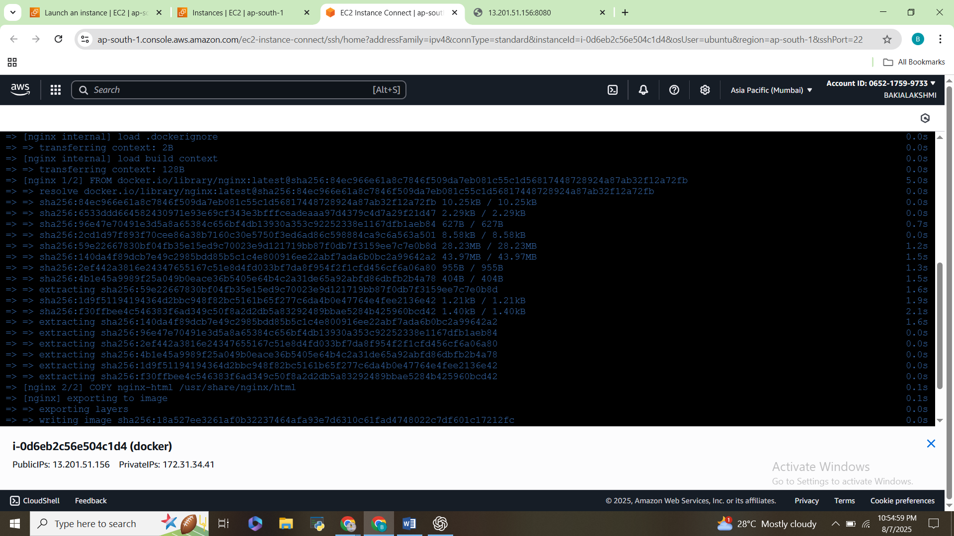

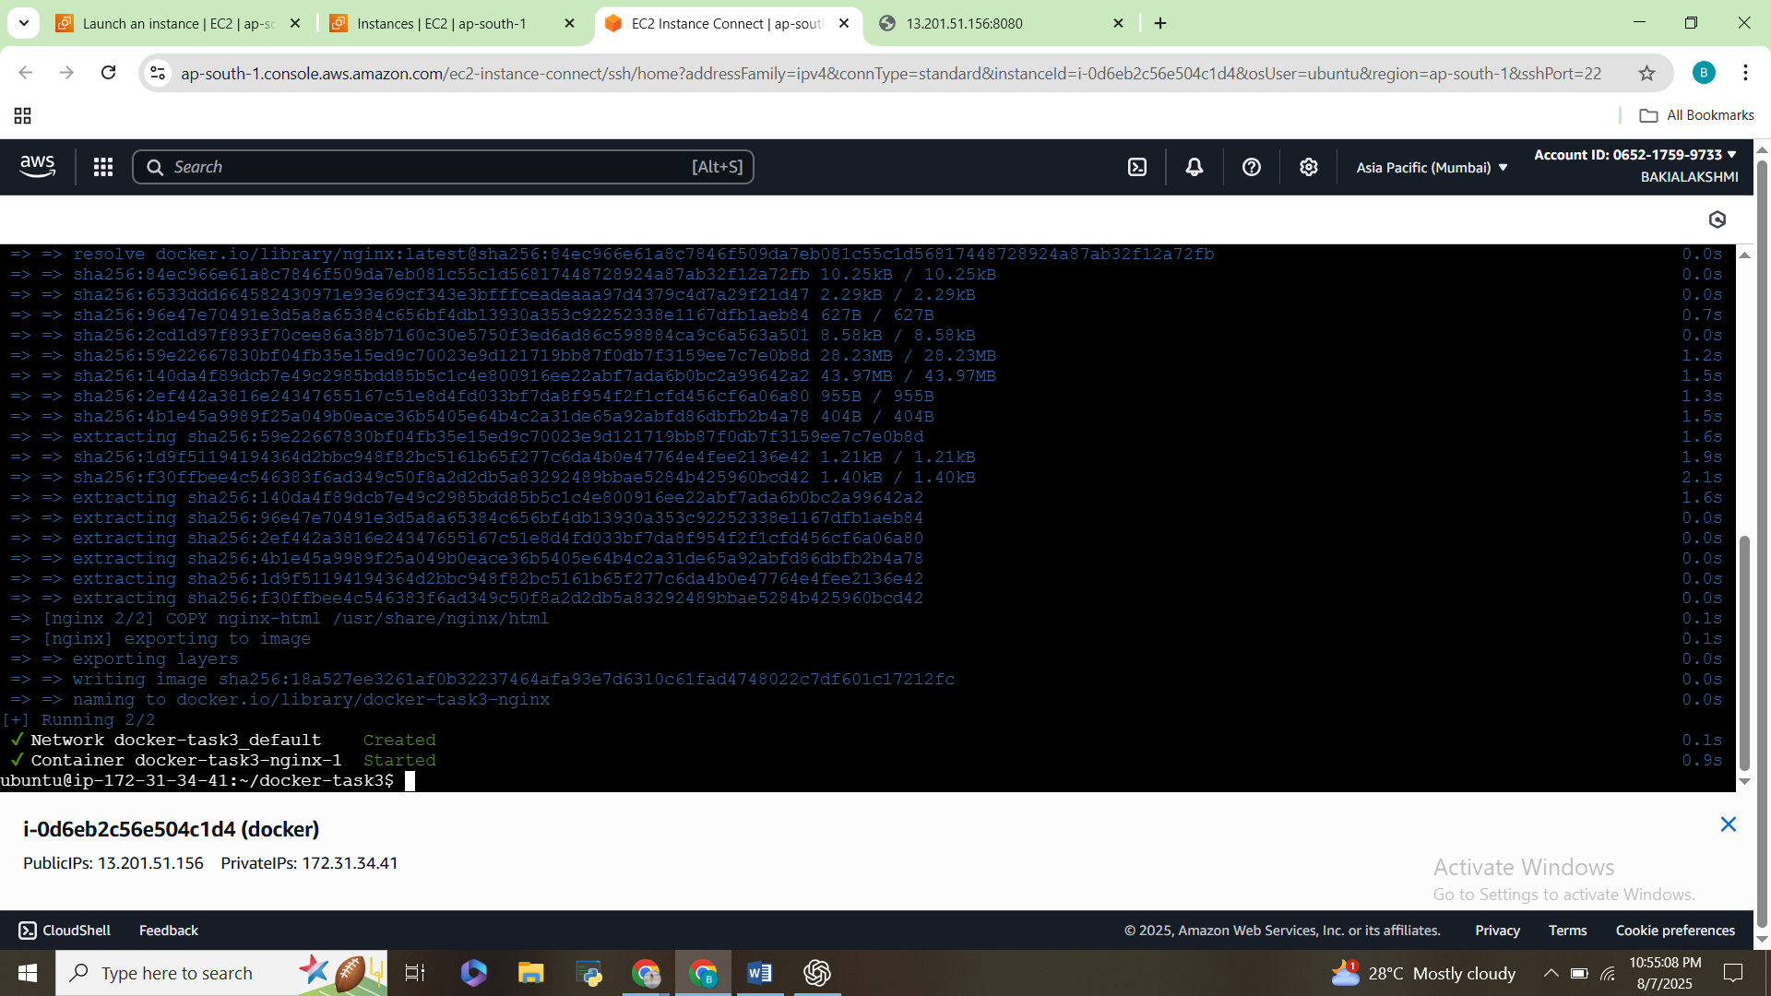

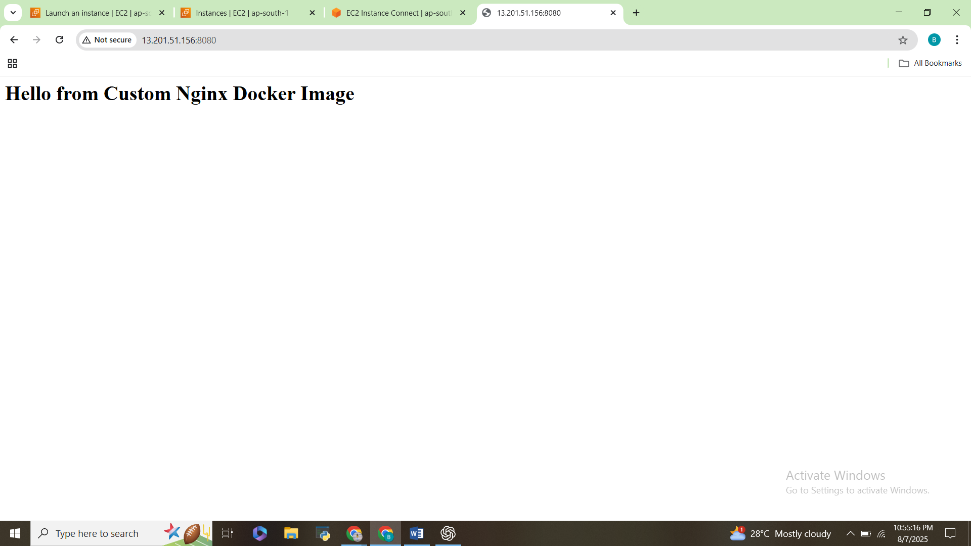

**3)Push the image to Docker Hub**

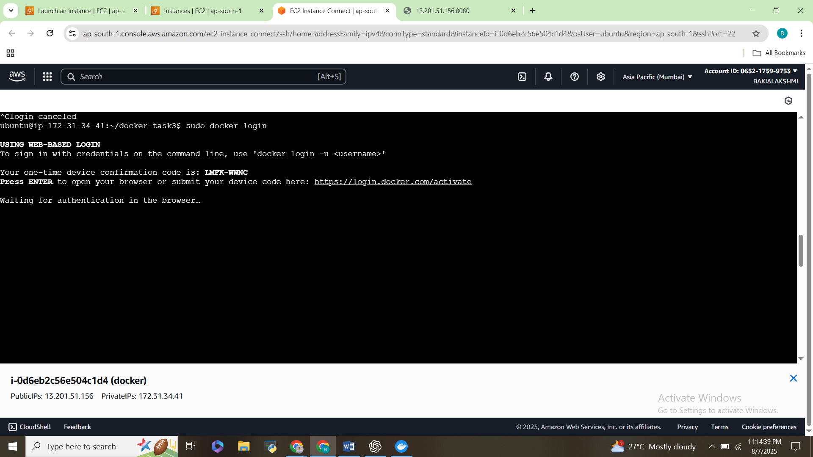

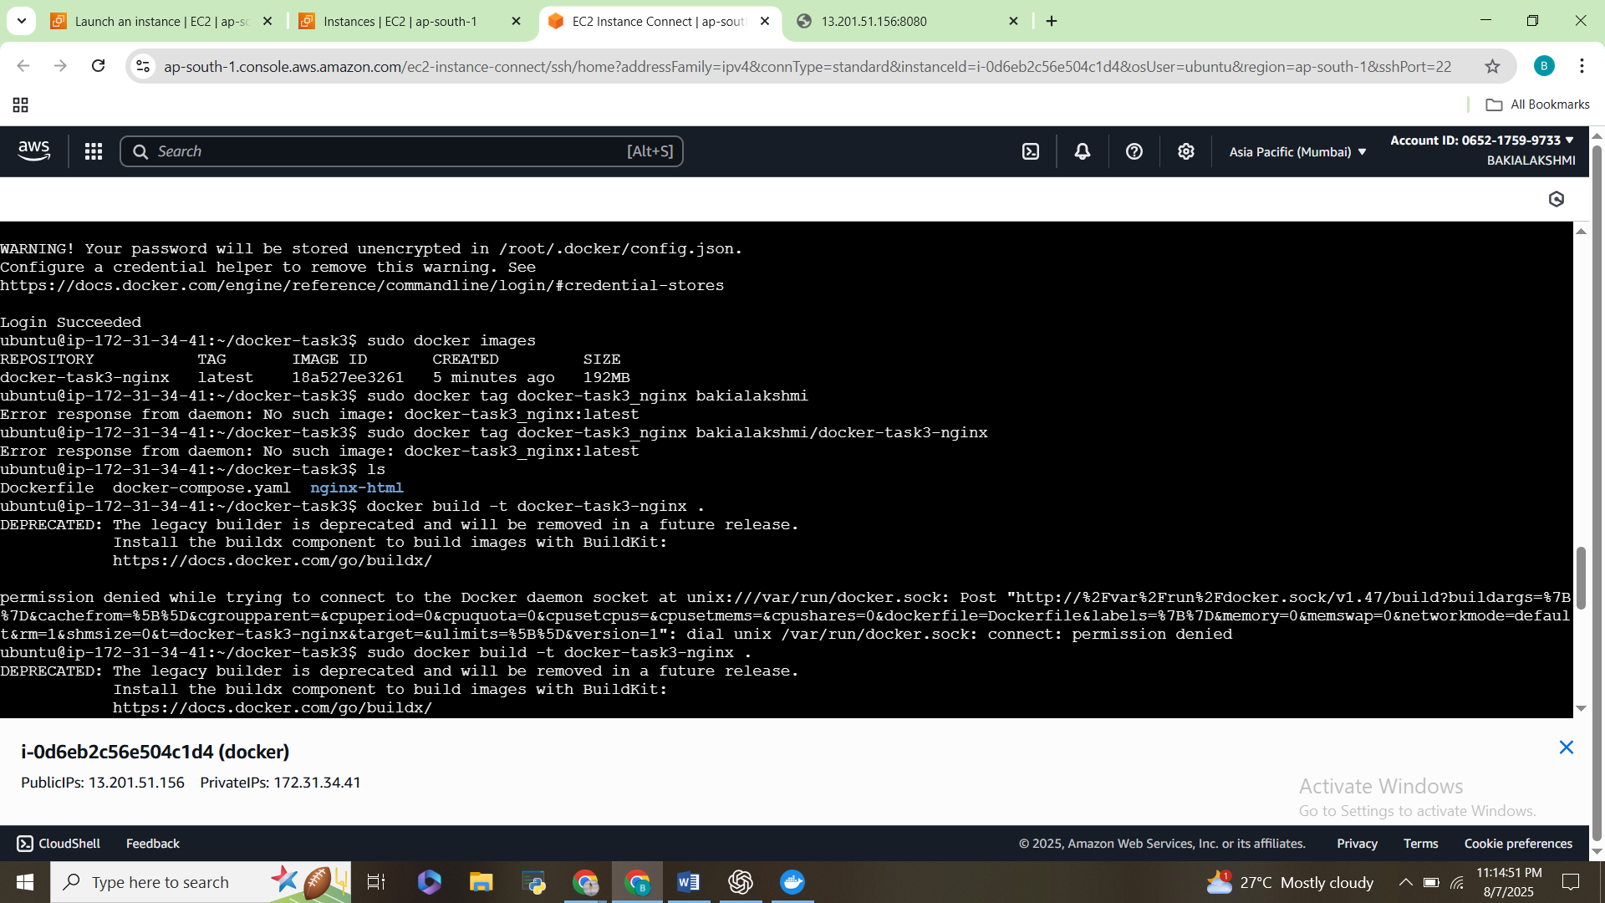

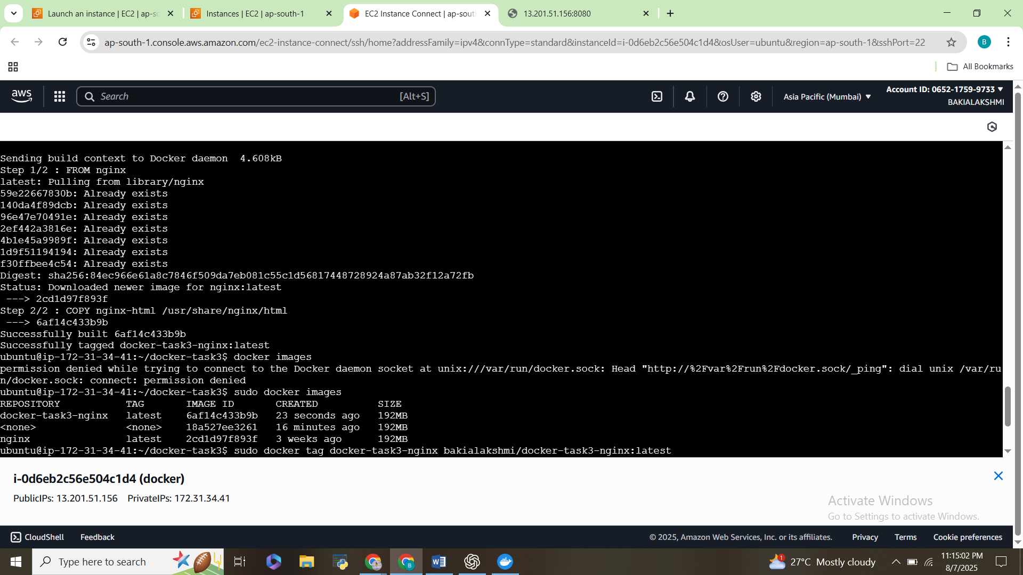

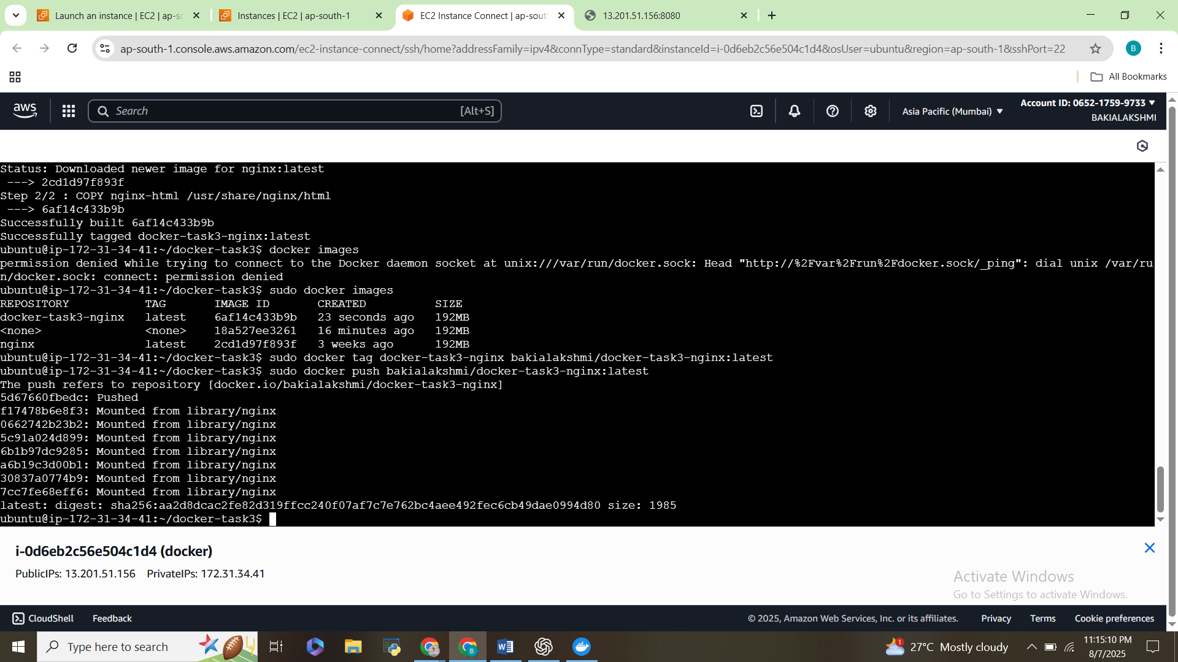

**4)Image is in Docker Hub**

